1)GitHub
It is a web based hosting service for software development projects that use the git revision control system. GitHub offers both paid plans for private repositories, and free accounts for open source projects. The site was launched in 2008 .

2)download Github from below link
http://windows.github.com/

3)Create acount and then create online repository.
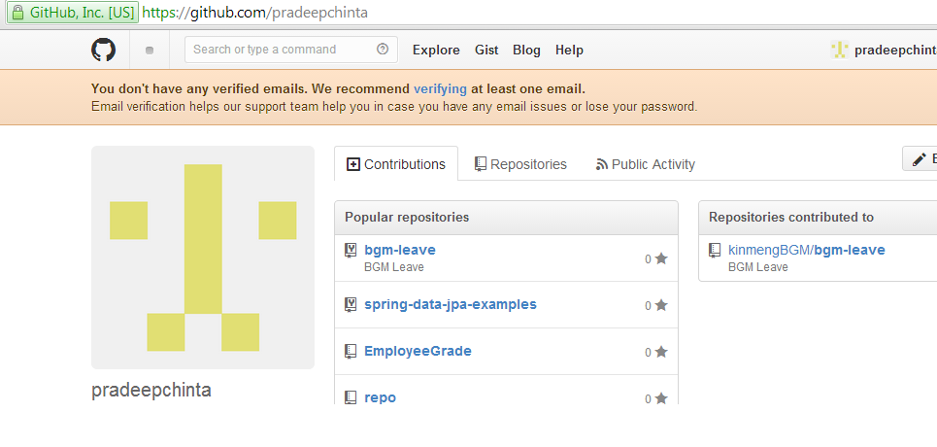

4)Simple Terminology
Checkout---------Get the files from repository.
Checkin--------- Store data into repository.
Git init-------Initializing the new repository.
Git add --------This does not add new files to your repository. Instead, it brings new files to Git’s attention.
Git help------ specific commands are available(if we forgot)
git push-------- commits data to the github
git pull-------- pull changes down to the github
git merge ------------- merge the data between two branches(master branch is default and another one is predefined) finally data stored in master branch only.

5)Create Local Repository
By using command prompt we can create local repository.
Steps:
1) git init ---> Initializing the new git repository
2)git add -------->This does not add new files to your repository. Instead, it brings new files to Git’s attention.

3)git commit -m "first commit" ----> commiting to the repository

4)git remote add origin https://github.com/pradeepchinta/EmployeeGrade.git

5) git push -u origin master ----->checkin our files into existing repository.
then it will ask username and password of your's
username:pradeepchinta
password:*********

---------------------------------- ------------------------------

6)Checkout the repository
Go to command prompt
git clone https://github.com/pradeepchinta/EmployeeGrade.git
It will create local clone of the repo then we work on it.
And then implement the code .
After that checkin code by using following commands
git init
git add filename (or) git add .
Git commit -m “update files”
Git push -u origin master
username:pradeepchinta
password:***********

7)Branches:

Branches are used to develop the isolated between each other.
Master -------->default branch for repository
Use other branches for development and merge them back to master branch
ex: create new branch temp
git checkout -b temp

------>switch from current branch to master
git branch master

8)Tagging:
It's recommed to create a tag for software releases.
git tag 1.0.0 nc84rb49u0
nc84rb49u0--- 1st 10 characters of commit id
git log ----->no of commits are done.
we can get commit id from this command line.

